**PIZZA SALES SQL QUERY DOCUMENTATION**

1. **KPI’s**

1.Total Revenue:

SELECT SUM(total_price) AS Total_Revenue

FROM pizza_sales

*Output:*

2.Average Order Value

SELECT SUM(total_price)/ COUNT(DISTINCT order_id) AS Avg_order_value

FROM pizza_sales

*Output:*

3.Total Pizza Sold

SELECT SUM(quantity) AS Tot_pizza_sold

FROM pizza_sales

*Output:*

4.Total orders

SELECT COUNT(DISTINCT order_id) AS Tot_orders

FROM pizza_sales

*Output:*

5.Average Pizzas Per Order

SELECT CAST(SUM(quantity) AS DECIMAL(10,2))/

CAST(COUNT(DISTINCT order_id) AS DECIMAL(10,2)) AS Avg_pizza_orders

FROM pizza_sales

*Output:*

1. **Chart Requirements**

1.Daily Trend for Total Orders

SELECT DATENAME(DW, order_date) as order_day,

COUNT(DISTINCT order_id) as Total_orders

FROM pizza_sales

group by DATENAME(DW, order_date)

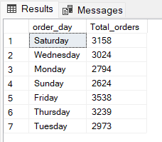*Output:*

2.Monthly Trend for Total Orders

SELECT DATENAME(MONTH, order_date) as Month_name,

COUNT(DISTINCT order_id) as Total_orders

FROM pizza_sales

group by DATENAME(MONTH, order_date)

order by Total_orders DESC

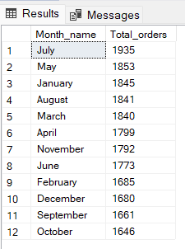*Output:*

3.Percentage of Sales by Pizza Category

SELECT pizza_category, CAST(SUM(total_price) * 100 / (

SELECT SUM(total_price) FROM pizza_sales WHERE MONTH(order_date)=1)

AS DECIMAL(10,2)) AS Per_cat_sales FROM pizza_sales

WHERE MONTH(order_date)=1

GROUP BY pizza_category

ORDER BY Per_cat_sales DESC;

*\*\* Note: In the above query the ‘WHERE MONTH(order_date)=1’ is a type of filter function, where I was used a January (as 1). You can change the number of month and get insights from it. \*\**

*Output:*

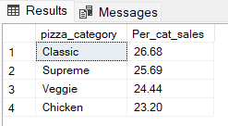

4.Percentage of Sales by Pizza Size

SELECT pizza_size, CAST(SUM(total_price) * 100 /

(SELECT SUM(total_price) FROM pizza_sales ) AS DECIMAL(10,2)) AS Per_size_sales

FROM pizza_sales

GROUP BY pizza_size

ORDER BY Per_size_sales DESC;

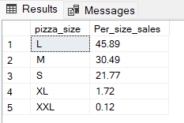*Output:*

5.Total Pizzas sold by Pizza Category

SELECT SUM(quantity) as Total_cat_sold, pizza_category

FROM pizza_sales

GROUP BY pizza_category

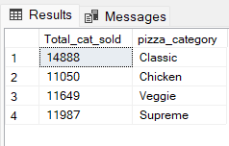*Output:*

6.Top 5 Best Seller by Total Pizzas sold

SELECT TOP 5 pizza_name, CAST(SUM(total_price) AS DECIMAL(10,2)) AS Total_Revenue

FROM pizza_sales

GROUP BY pizza_name

ORDER BY Total_Revenue DESC

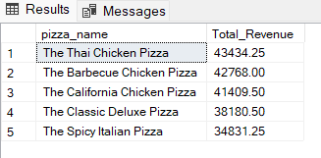*Output:*

7.Bottom 5 worst sellers by Total Pizzas sold

SELECT TOP 5 pizza_name, CAST(SUM(total_price) AS DECIMAL(10,2)) AS Total_Revenue

FROM pizza_sales

GROUP BY pizza_name

ORDER BY Total_Revenue ASC;

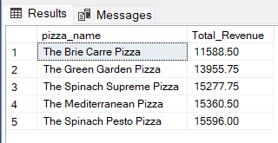*Output:*

8.Top 5 Pizzas by Quantity

SELECT TOP 5 pizza_name, SUM(quantity) AS Total_quantity

FROM pizza_sales

GROUP BY pizza_name

ORDER BY Total_quantity DESC;

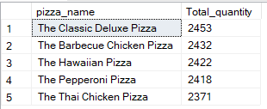*Output:*

9.Bottom 5 Pizzas by Quantity

SELECT TOP 5 pizza_name, SUM(quantity) AS Total_quantity

FROM pizza_sales

GROUP BY pizza_name

ORDER BY Total_quantity ASC;

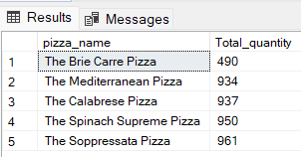*Output:*

10.Top 5 Pizzas by Orders

SELECT TOP 5 pizza_name, COUNT(DISTINCT order_id) AS Total_orders

FROM pizza_sales

GROUP BY pizza_name

ORDER BY Total_orders DESC;

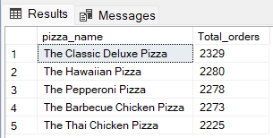*Output:*

11.Bottom 5 Pizzas by Orders

SELECT TOP 5 pizza_name, COUNT(DISTINCT order_id) AS Total_orders

FROM pizza_sales

GROUP BY pizza_name

ORDER BY Total_orders ASC;

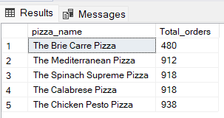*Output:*